AFTER LOGIN TO AWS CONSOLE

STEP:1 CLICK ON COMPUTE AND MOVE TO EC2 INSTANCE

STEP:2 LAUNCH INSTANCE

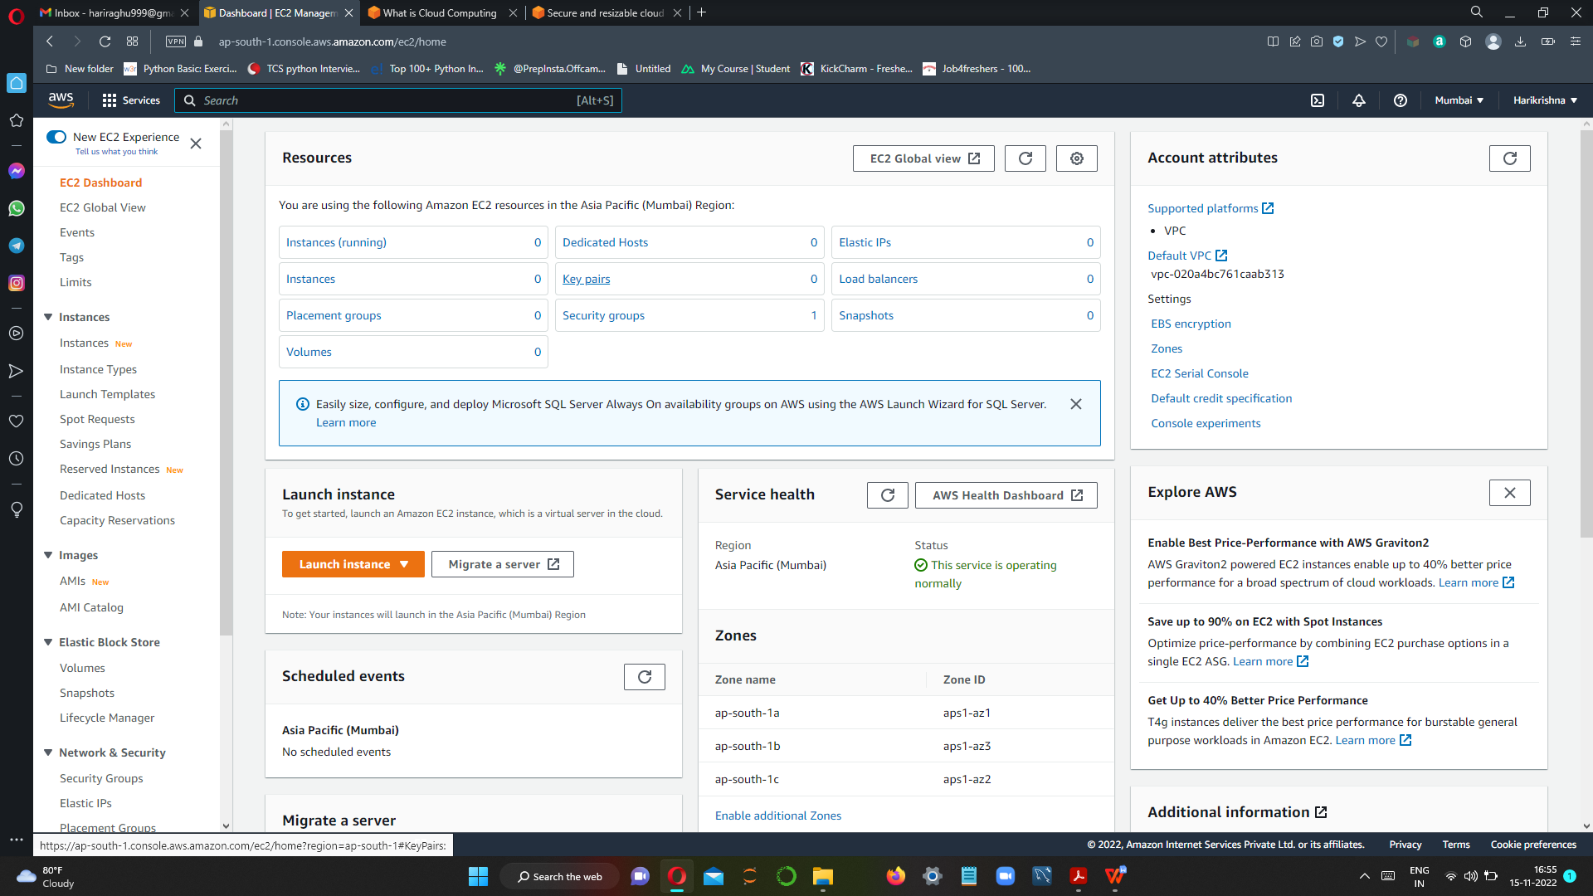

STEP:3 CHOOSE AMI

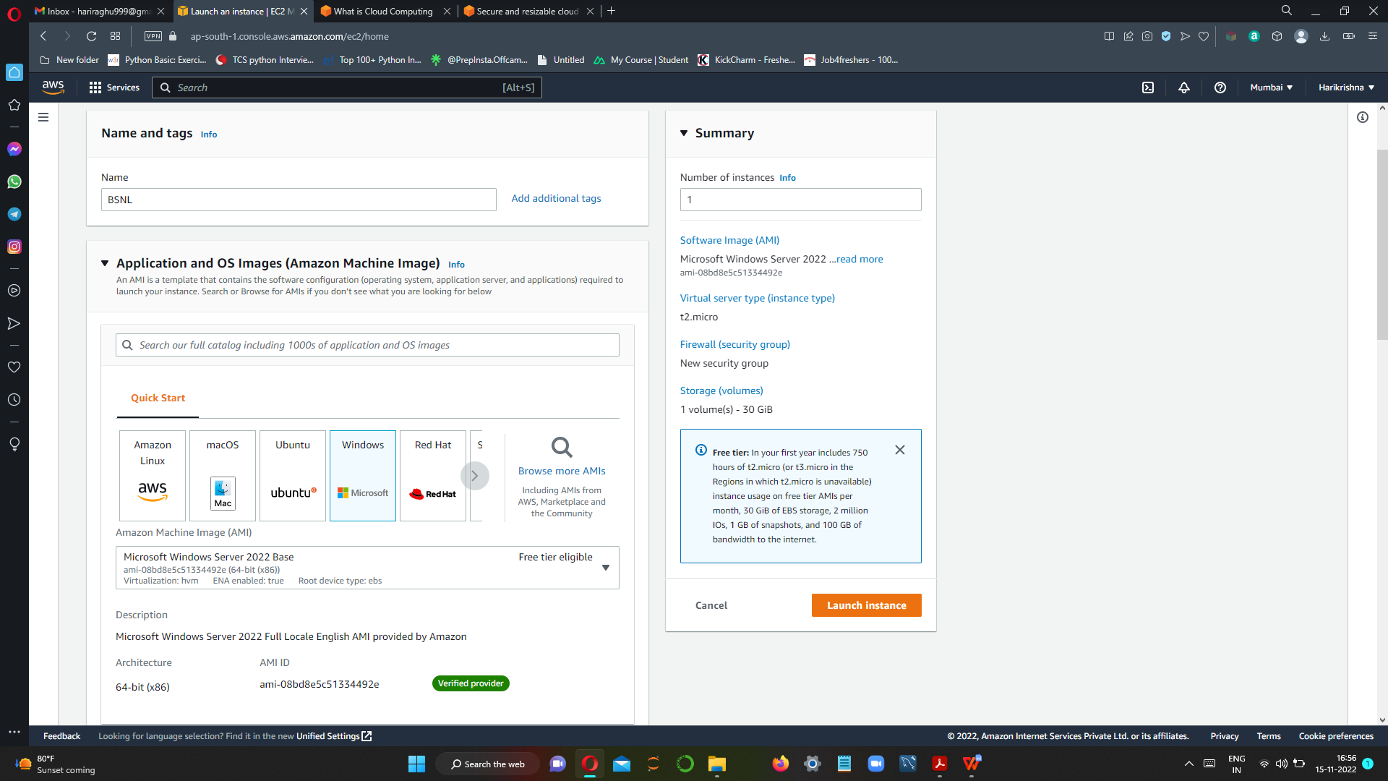

STEP:4 CHOOSE INSTANCE TYPE

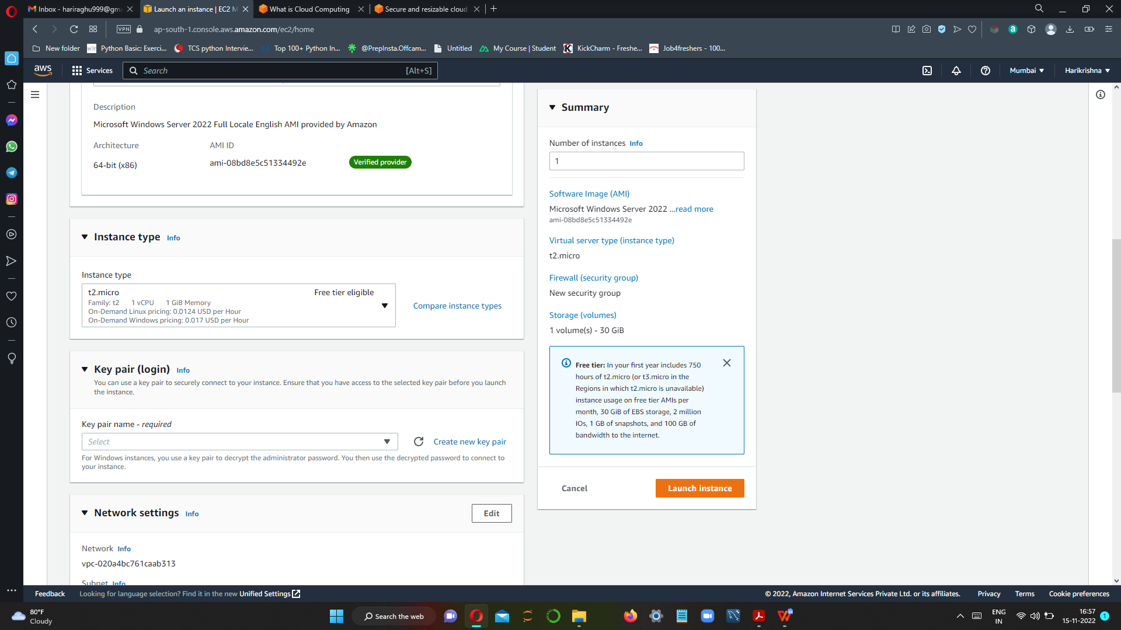

STEP:5 SETUP KEY PAIR

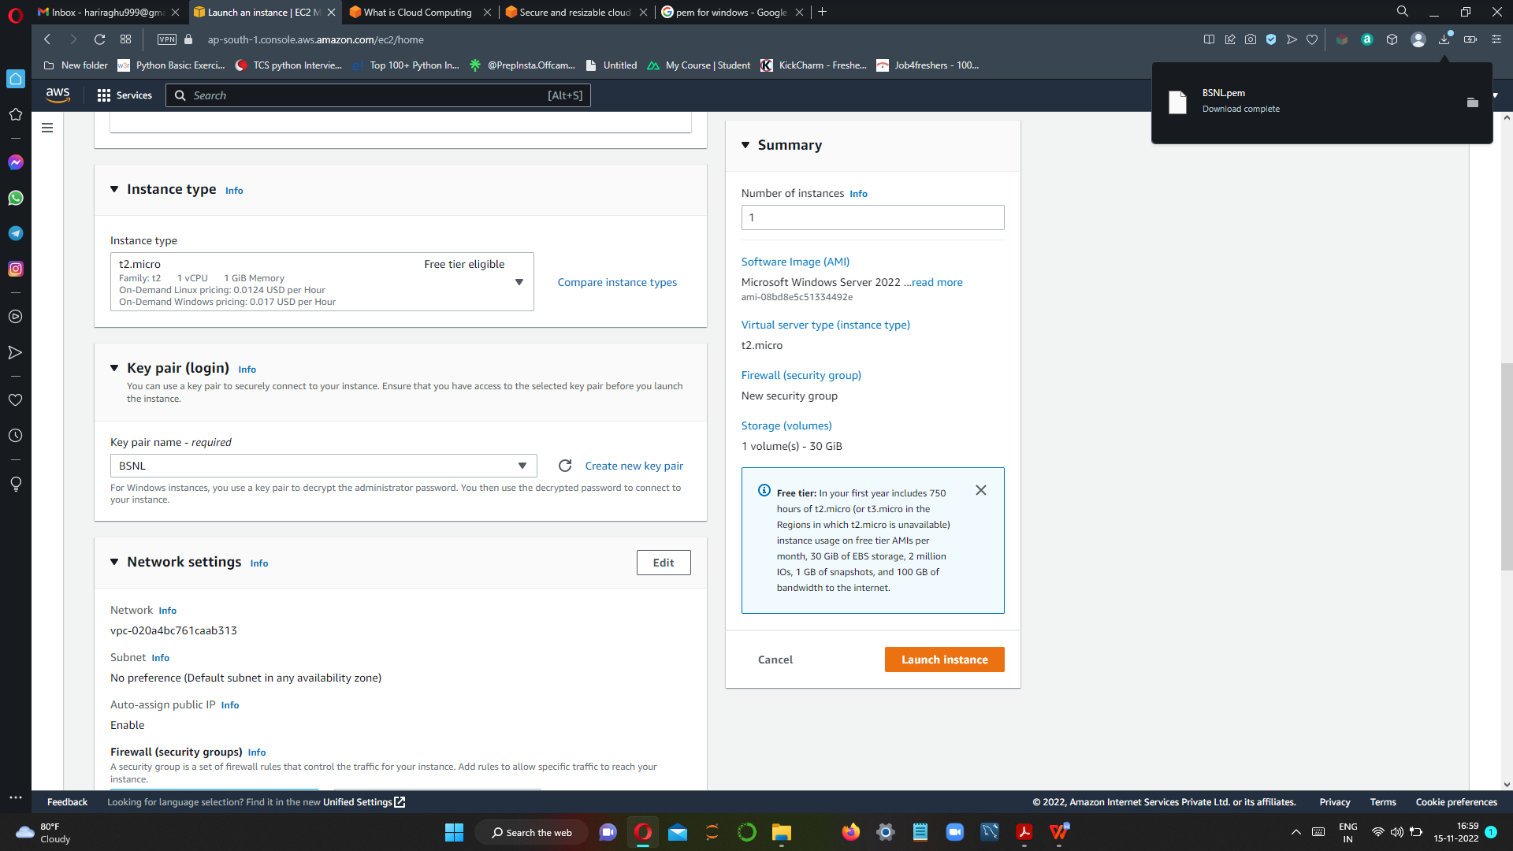

STEP:6 SETUP NETWORK CONFIGURATION

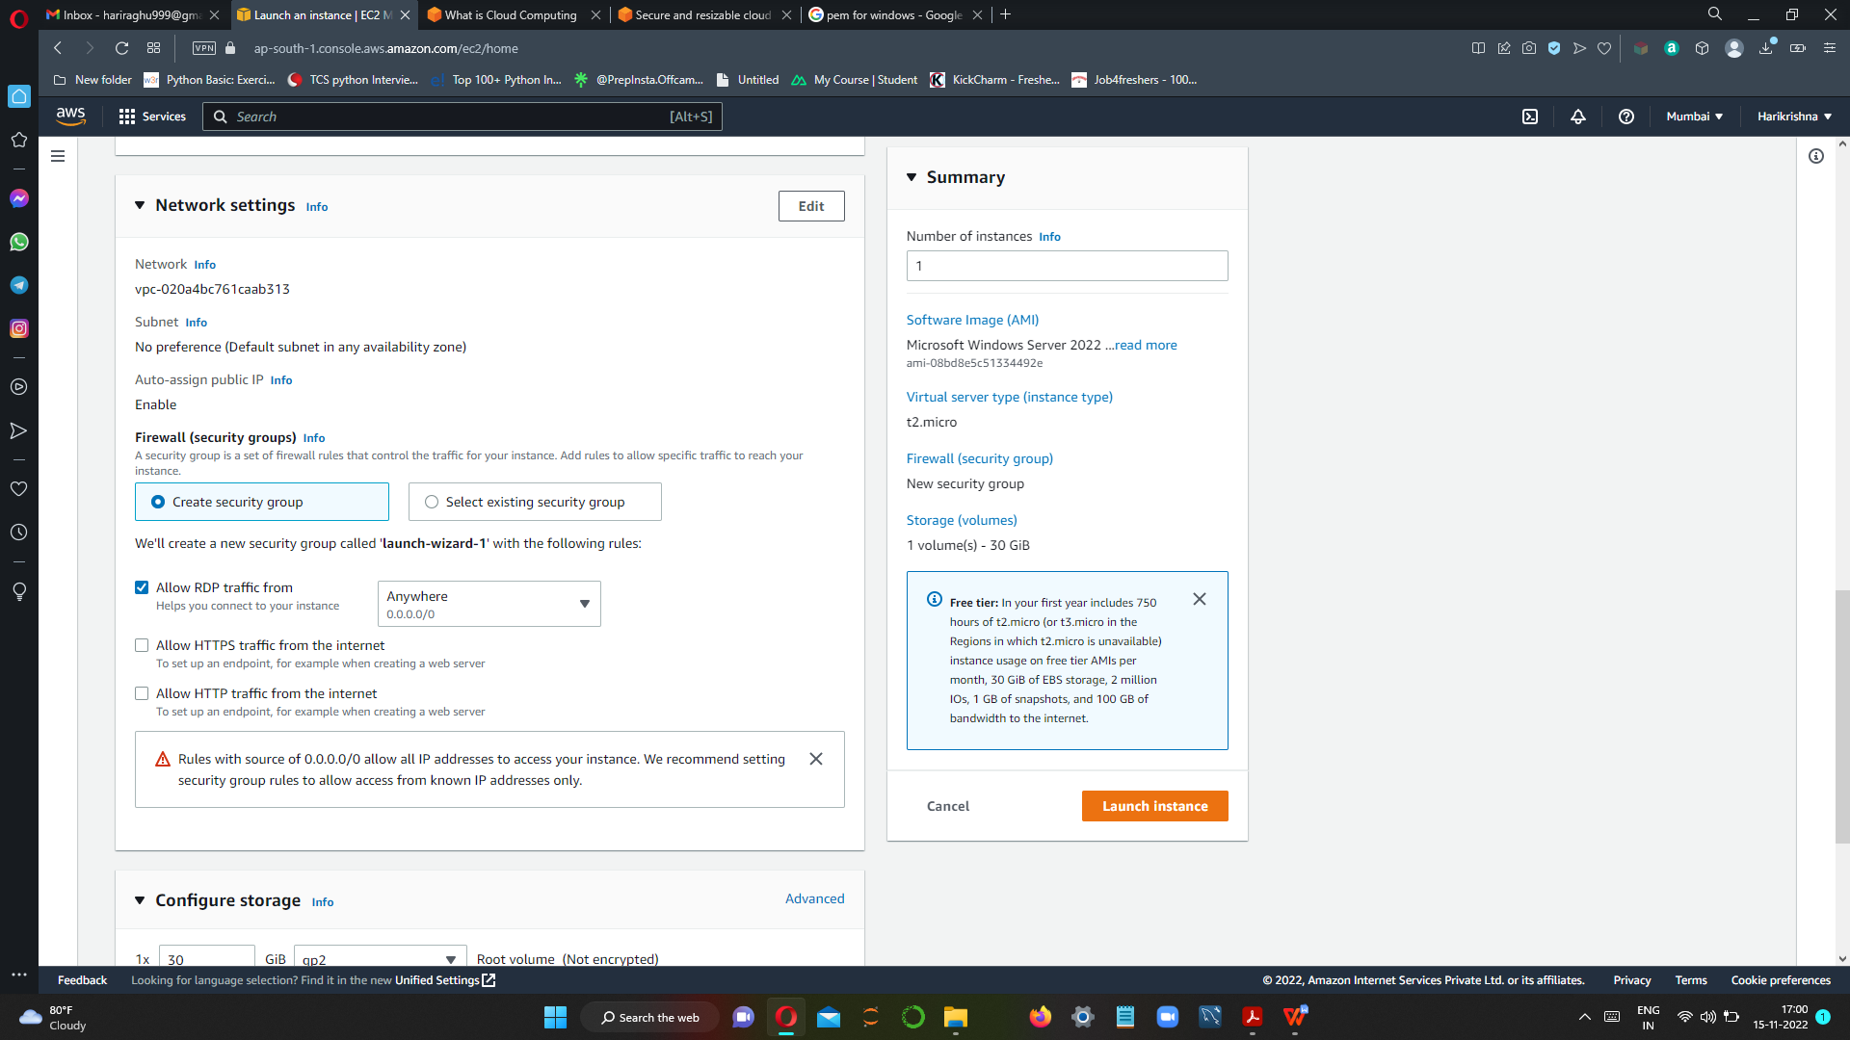

STEP:7 ADD STORAGE

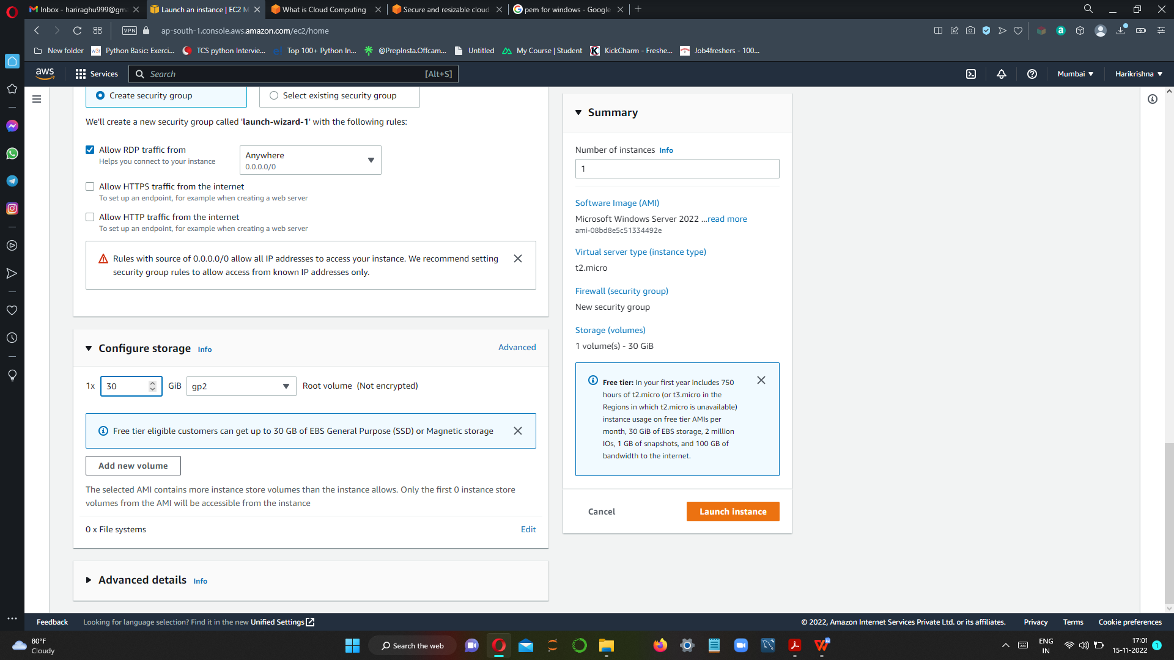

STEP8: LAUNCH INSTANCE

